AUTOMATIC OPEN AND CLOSE DOOR SYSTEM BY USING ULTRASONIC

**Abstract:**

Opening and closing of doors have always been a tedious and boring job, especially in places like; hotels, shopping malls, theaters, etc where a person is always required to open and close the door for visitors. This human involvement can be avoided by automating the process using different sensors like infrared, pressure, ultrasonic, laser etc. In this paper, automatic door control system using Arduino microcontroller was designed. The system combines ultrasonic sensor, servo(2) connected in parallel,led(2) and Arduino to achieve the desired goal. When the ultrasonic sensor installed at the entrance of the building detects a person or an object within the range of the sensor, a signal is sent to the Arduino microcontroller which controls the servo motor to automatically open the door. The door remains open until the object goes out of range of the sensor and in turn closes the door automatically. The results clearly show that the system is cheap, effective, and a reliable means of opening and closing doors in places like retail stores, super markets, factories and the like.

**. Introduction :**

The market for automated doors is growing and becoming more specialized. The type of product that fits best with a particular application is determined by frequency of operation, speed of operation required, new versus existing construction, traffic flow and cost. Automatic doors are a normal feature in many commercial buildings and infrastructures such as shopping centers and airports, as well as in industrial environments such as factories. Although they come in variety of types, including sliding, swing, folding, etc; they all need to conform to the highest standards of safety.

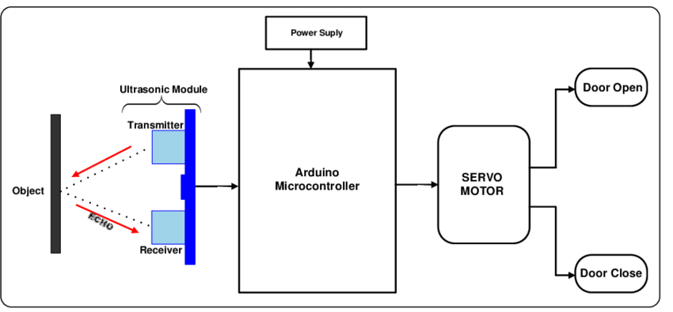

In an industrial environment, automatic doors enables the set temperature in cold storage rooms to be maintained by fast opening and closing, leading to considerable energy efficiency and reduction of cost. Automated doors in commercial facilities are the preferred means of access for all users, not only people with disabilities, and are significant aid to accessibility. Moreover, their use minimizes heat or air conditioning loss, maintaining a constant temperature and consequently saving money.

**ALL MATERIAL WE CAN USED AND ITS FUNCTION**

* ULTRASONIC SENSOR
* ARDUINO UNO
* BREAD BOARD
* SERVO MOTORS(2)
* JUMPER WIRES
* BUZZER
* **ULTRASONIC SENSOR**

The ultrasonic sensor emits short and high frequency signal. These signals propagate in the air at the velocity of sound. If there is an object or obstacle on its path, it will bounce back to the module. The ultrasonic sensor consists of a multi vibrator, fixed to the base. The multi vibrator is combination of a resonator and vibrator. The resonator delivers ultrasonic wave generated by the vibration. The ultrasonic sensor actually consists of two parts; the emitter which produces a 40 kHz sound wave and a detector that detects 40 kHz sound wave and sends electrical signal back to the Arduino microcontroller [3].

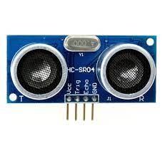

The HC-SR04 ultrasonic module used in this project has 4 pins, ground, VCC, trig and echo. The Ground and the VCC pins of the module needs to be connected to the ground and the 5 volts pins on the Arduino board respectively and the trig and echo pins to any digital I/O pin on the Arduino board.

* **ATRDUINO UNO**

Arduino is a small microcontroller board with a USB plug to connect to computer. It has number of connection sockets that can be wired up to external electronics, such as motors, relays, light sensors etc. They can either be powered through the USB (universal serial box) connection from the computer or from a 9V battery. They can be controlled from the computer or programmed by the computer and then disconnected and allowed to work independently.

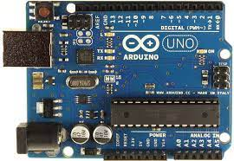

Arduino UNO- The Arduino Uno is a microcontroller board based on the ATmega 168. It has 14 digital input/output pins (of which 6 can be used as PWM (pulse width modulation) outputs), 6 analog inputs, a 16 MHz ceramic resonator, a USB connection, a power jack, an ICSP (in-circuit serial programming) header, and a reset button. It contains everything needed to support the microcontroller; simply connect it to a computer with a USB cable or power it with an AC-to-DC adapter or a battery to get started.

* **BREAD BOARD**

is used for building temporary circuits. It is useful to designers because it allows components to be removed and replaced easily.

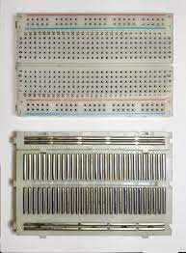

* **SERVO MOTORS**

A Servo is a small device that incorporates a three wire DC motor, a gear train, a potentiometer, an integrated circuit, and an output shaft bearing. Of the three wires that stick out from the motor casing, one is for power, one is for ground, and one is a control input line. The shaft of the servo can be positioned to specific angular positions by sending a coded signal. As long as the coded signal exists on the input line, the servo will maintain the angular position of the shaft. If the coded signal changes, then the angular position of the shaft changes. A very common use of servos is in radio controlled models like cars, airplanes, robots, and puppets. They are also used in powerful heavy-duty sail boats. Servos are rated for speed and torque.

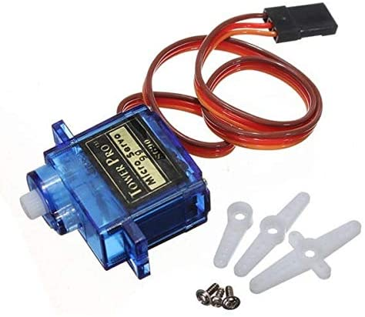

* **JUMPER WIRES**

 A jumper wire is an electric wire that connects remote electric circuits used for printed circuit boards.

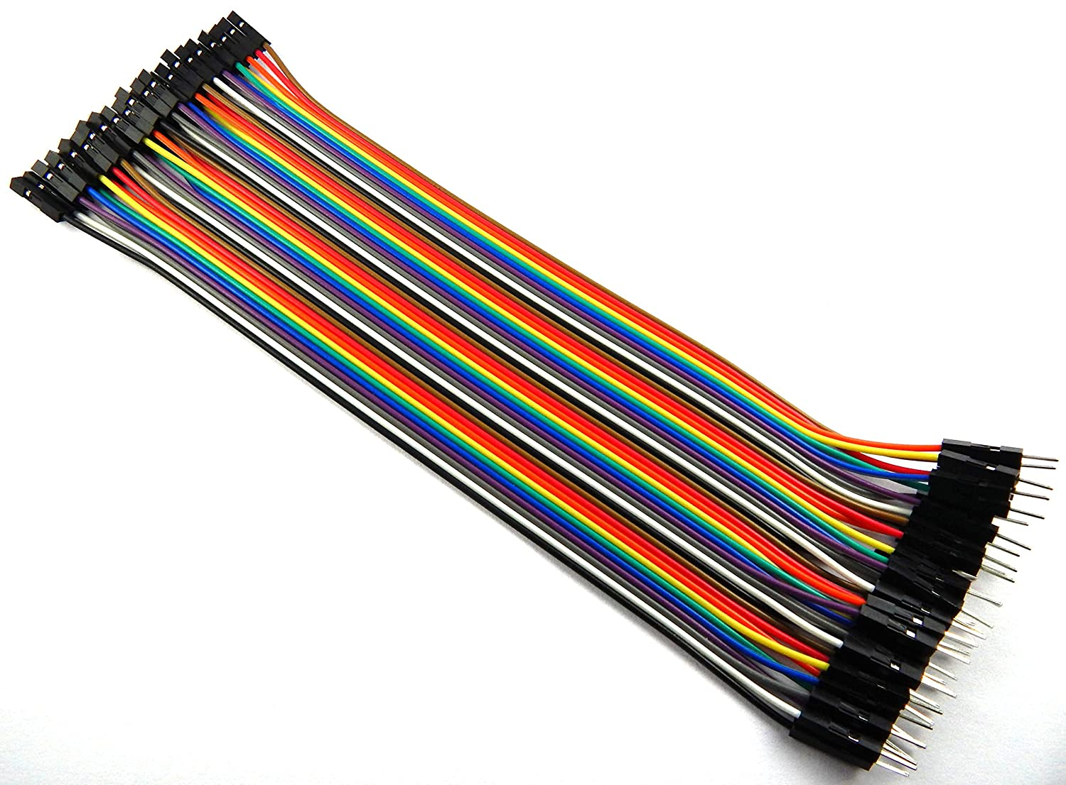

WORKING PRINCIPLE

Working Principle of Arduino based door automation system using ultrasonic sensor and servo motor illustrated in figure 9 is as follows: If there is no person or object within radar of the ultrasonic sensor (10cm), the door remains closed . But if there is an object or a person within the ultrasonic radar, the door will automatically open.

The door will remain open until the object goes out of the ultrasonic radar, then it will automatically close. The system is setup with one Ultrasonic sensor (in front) for ease purpose, but can be extended by adding another sensor at the back using the same process. This will help to automate entry and exit of our system.

CODE

#include<Servo.h>

Servo myservo;

int pos=20;

const int trigpin=5;

const int echopin=6;

const int led1=2;

const int buzzer=3;

long duration;

float distance;

void setup()

{

myservo.attach(11);

pinMode(trigpin,OUTPUT);

pinMode(echopin,INPUT);

pinMode(led1,OUTPUT);

pinMode(buzzer,OUTPUT);

myservo.write(pos);

}

void loop()

{

//serial.begin(9600);

digitalWrite(trigpin,LOW);

delayMicroseconds(2);

digitalWrite(trigpin,HIGH);

delayMicroseconds(10);

digitalWrite(trigpin,LOW);

duration=pulseIn(echopin,HIGH);

distance=0.034*(duration/2);

//serial.println(distance);

if(distance>27)

{

digitalWrite(led1,HIGH);

digitalWrite(buzzer,LOW);

delay(500);

}

else

{

digitalWrite(led1,LOW);

digitalWrite(buzzer,HIGH);

delay(400);

}

if(distance<27)

{

myservo.write(pos+160);

delay(1000);

}

else

{

myservo.write(pos);

}

delay(300);

}

**CONCLUSION**

This paper presented a prototype of Arduino bases door automation system using ultrasonic sensor and servo motor. The door automation system uses ultrasonic sensor to detect presence of human or an object within its radar and sends a signal to Arduino microcontroller who instructs the servo motor to open the door and keeps it open. Once the object is out of the ultrasonic sensor radar, it sends another signal to the microcontroller for it to instruct the servo motor to close the door automatically.

Since the door is opened only when a person is detected and remains close all other times, it can save a lot of energy in the form air conditioning and can be useful for aged and disabled person